○ It’s convenient to pay tax by bank (account to account) transfer
Your tax will be paid automatically from your bank account, so you will never forget to make a payment.

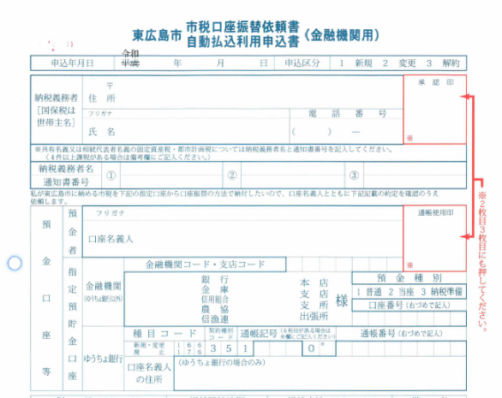
The signature or stamp you registered at the bank

Address
Name
Name
Bank name
Branch name
Account number, etc.

